Jesus According to Zacchaeus
(Luke 19:1-10)
Pastor Datuk Kee Sue Sing

Jesus entered Jericho and was passing through. A man was there by the name of Zacchaeus; he was a chief tax collector and was wealthy. He wanted to see who Jesus was, but because he was short he could not see over the crowd. So he ran ahead and climbed a sycamore-fig tree to see him, since Jesus was coming that way.

When Jesus reached the spot, he looked up and said to him, “Zacchaeus, come down immediately. I must stay at your house today.” So he came down at once and welcomed him gladly.

All the people saw this and began to mutter, “He has gone to be the guest of a sinner.”

But Zacchaeus stood up and said to the Lord, “Look, Lord! Here and now I give half of my possessions to the poor, and if I have cheated anybody out of anything, I will pay back four times the amount.”

Jesus said to him, “Today salvation has come to this house, because this man, too, is a son of Abraham. For the Son of Man came to seek and to save the lost.” (Luke 19:1-10)

BIG IDEA:
There is no one so sinful, that God doesn’t love them.

He saw me (Luke 8:40-44; 1 Samuel 16)

A man was there by the name of Zacchaeus; he was a chief tax collector and was wealthy. He wanted to see who Jesus was, but because he was short he could not see over the crowd. (Luke 19:2-3)

- A short man
All of us has fallen short of the glory of God. We may not be short physically, but we may be short on love, joy, peace, faith, purpose in life and etc. However, we can stand tall in Jesus Christ.

- A notorious and despised man
Tax collectors were Jews who collected taxes for the Romans, and Zacchaeus is a chief tax collector. They had access to the Roman authorities, and they can go to anyone to enforce payment. They were considered cheats and robbers by the Jews, their own people. They were not allowed to go into the synagogue because they were considered unclean.

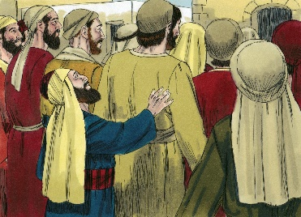
- A determined man
Jesus entered Jericho and was passing through. Everyone wanted to see Jesus, they were lining up and crowding around to see Him, and Zacchaeus wanted to see Him too. People would have made way for a respected man to pass through, but they would not let Zacchaeus through. Despite the obstacles Zacchaeus faced in his desire to see Jesus, he did not give up and return home. He saw a sycamore-fig tree and climbed it. A sycamore tree is easy to climb and has many leaves which can conceal a person.
Zacchaeus did not care if people will think of him as childish for a grown man to climb a tree. He was determined to see Jesus. Curiosity and simplicity are a sort of preparation for faith. The Holy Spirit must be at work in Zacchaeus’ life, and deep down, he longed to be accepted just like everyone else.
Prevenient grace: God’s grace that goes before us, wooing us, calling us into the arms of His love.

God always gives us a chance to know Him more deeply, and to encounter Him. The Holy Spirit prompts us to draw close to Him, therefore let us not miss this chance. When God’s Spirit is dealing with us, let us not brush it off. The prompting of the Holy Spirit may cease. This is the last time Jesus is walking through Jericho before He was crucified. Zacchaeus might miss this chance to see Jesus and to encounter Him, and his life will remain the same as it was before.

- A surprised man
If Zacchaeus meant to hide when he climbed up the sycamore tree, he had been discovered when Jesus reached the tree and called to him.

He welcomed me

When Jesus reached the spot, he looked up and said to him, “Zacchaeus, come down immediately. I must stay at your house today.” (Luke 19:5)

The word ‘immediately’ in Greek is ‘speudo’, which means to hurry and to hasten.
The word ‘must’ means that it is necessary, denoting a sense of compulsion.

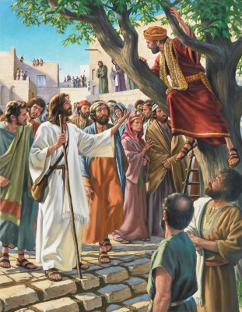
- A personal relationship
Jesus invites us into a personal relationship with Him. He stands at the door of our hearts and knocks, and He waits for us to welcome Him in. Jesus is not too busy saving the world to care for people like Zacchaeus, those who have been rejected, despised and abandoned. Zacchaeus came down at once and welcomed Jesus gladly. Uncontrollable joy is the response to such grace.

- The guest of a sinner
All the people saw this and began to mutter, “He has gone to be the guest of a sinner.”

The word ‘mutter’ in Greek is ‘diagogguzo’, which means to grumble aloud and to complain.

It is sad that people are grumbling and complaining instead of rejoicing over a sinner that has been saved. Jesus did not care about the scandal. He cared about the scandaler. He welcomed them.

He changed me

- The touch of love
Medical science has proven that babies who are held and touched develop faster than those who have been left alone. Likewise, the touch of Jesus changes us too.

This is why the ministry of presence is important, which is to just be there for people, to spend time with them. This has the ability to change lives.

- The proof of transformation
But Zacchaeus stood up and said to the Lord, “Look, Lord! Here and now I give half of my possessions to the poor, and if I have cheated anybody out of anything, I will pay back four times the amount.” (Luke 19:8)

The fruit of Zacchaeus’ faith can be seen. This is in accordance to the Scriptures on God’s commands about restitution for wrongs.

The Lord said to Moses, “Say to the Israelites: ‘Any man or woman who wrongs another in any way and so is unfaithful to the Lord is guilty and must confess the sin they have committed. They must make full restitution for the wrong they have done, add a fifth of the value to it and give it all to the person they have wronged. (Numbers 5:5-7)

Conclusion
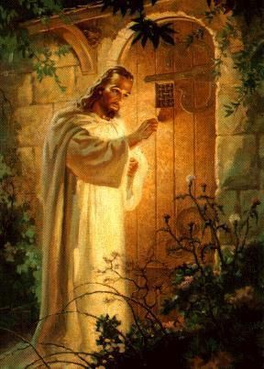
Jesus said to him, “Today salvation has come to this house, because this man, too, is a son of Abraham. For the Son of Man came to seek and to save the lost.” (Luke 19:9-10)

Jesus is always at work in the hearts and lives of people. He never turns away from anyone who turns away from Him. Do not turn away when the Holy Spirit is prompting you into an encounter with Jesus, for that can change your life. When He stands at the door of your heart and knock, open your heart to Him.

Sermon summary by Anthea.

