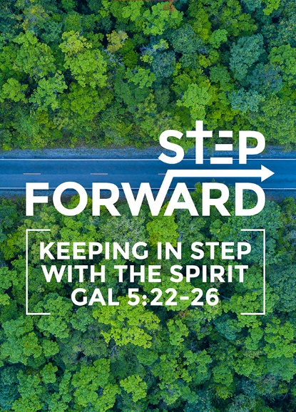
Studies in the Book of Galatians 6: The Christian’s Duty (Gal 6:1-5)
Senior Pastor Chris Kam

Brothers and sisters, if someone is caught in a sin, you who live by the Spirit should restore that person gently. But watch yourselves, or you also may be tempted. Carry each other’s burdens, and in this way you will fulfill the law of Christ. If anyone thinks they are something when they are not, they deceive themselves. Each one should test their own actions. Then they can take pride in themselves alone, without comparing themselves to someone else, for each one should carry their own load. (Galatians 6:1-5)

We all like to give advice. Pastor Chris shared that he has received many advices from members over the years. Some were helpful and some not so practical. We all like to be helpful. When we give advice, we must not be condescending but we need to approach it in a loving manner, in “Loving restitution”. Afterall we are all sinner.

The Order for the Reception of Members into the Church

Pastor:
Brothers and sisters of Damansara Utama Methodist Church, I commend to your love and care these persons whom we this day receive into the membership of this congregation. Do all in your power to increase their faith, confirm their hope, and perfect them in love.

Congregation:
We rejoice to recognize you as members of Christ’s holy Church, and bid you welcome to this congregation of Damansara Utama Methodist Church. With you we renew our vows to uphold it by our prayers, our presence, our gifts, and our service.

We need to recognise that we have a duty to our members, to increase their faith, confirm their hope, and perfect them in love

The Task - Be Responsive to Others (Galatians 6:1-2)
Brothers and sisters, if someone is caught in a sin, you who live by the Spirit should restore that person gently. But watch yourselves, or you also may be tempted. Carry each other’s burdens, and in this way you will fulfill the law of Christ. (Galatians 6:1-2)

If you bite and devour each other, watch out or you will be destroyed by each other. So I say, walk by the spirit and you will not gratify the desires of the flesh. (Galatians 5:15-16)

Even as Christians we can “bite” each other. Paul had his fair share of being ‘bitten’. Despite this Paul still called the Galatians “brothers and sisters”. We are still family. We need to show love.

In Romans 14:1-15:13, Paul talks about ‘stronger brothers’ and ‘weaker brothers’ (this also refers to sisters). The stronger brother is a person who are spiritually older and the weaker brother spiritually younger. The stronger brother is supposed to help the weaker brother in love.

There are times that we desire to be Christlike but we ‘unknowingly’ fall into sin. We did not plan to sin but we end up in sin. Yes, we need to take responsibility of the sin. We need to take sin seriously. The Christian’s duty is to lovingly restore our brother, to restore the Body of Christ. It is not about Me, it is about restoring with humility. The goal of Christianity is the health and growth of the Body of Christ.

As we restore, we must not have pride.
There is danger for both stronger and weaker.
- For the Stronger brother – develop spiritual pride.
- For the Weaker brother – do not want to be restored and run away.

To the older brother, Paul says, “Accept the one whose faith is weak, without quarreling over disputable matters.” (Romans 14:1).

The Test - Be Realistic About Yourself (Galatians 6:3-4)
If anyone thinks they are something when they are not, they deceive themselves. Each one should test their own actions. Then they can take pride in themselves alone, without comparing themselves to someone else, (Galatians 6:3 - 4)

As we help others, we can develop spiritual pride. We should first test ourselves before we judge others.

We are constantly comparing ourselves to people around us, those who are better and those who are ‘below’. We become performance base. It is not about how much or how little we do for the Body of Christ, it is about how faithful to the gifts that God has given

The Trust - Be Responsible to God (Galatians 6:5)
for each one should carry their own load. (Galatians 6:5)

This seems to contradict verse 2 “Carry each other’s burdens”. There are 2 different words here, “Burden” and “Load”.
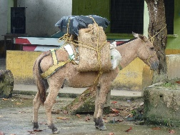

Burden (Galatians 6:2) is referring to burden on a donkey. The donkey has been overloaded and is not able to move. Some of the burden has to be removed in order that the donkey to move.

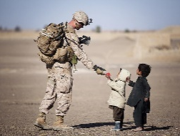
Load (Galatians 6:5) refers to a soldier’s backpack. This backpack is a survival pack. It contains everything that the soldier needs. These things are for ourselves, our own responsibility, like to study the bible, spending time with God, prayer, loving others / someone, attend to cell group, attend church, etc.

We need to be clear what are burdens and what are loads. Help others with the burdens and take responsibility for our loads.

Conclusion
There are 2 groups of people
- Those who are hurting, who needs to be restored. Those who were wounded by the way they were helped.
- Those who are trying to help others, who thinks that they are better then others. Bring your spiritual pride to God. Learn to lovingly restore others.
Come and bring it before God. Release into His hands the people or situations.

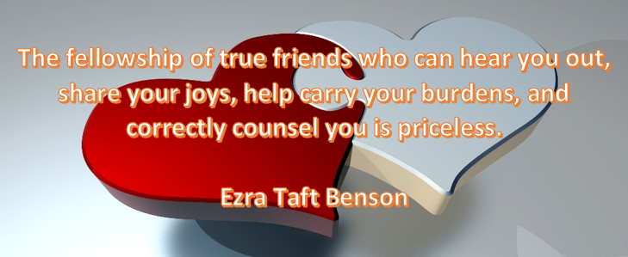

Sermon summary by Prudence.

