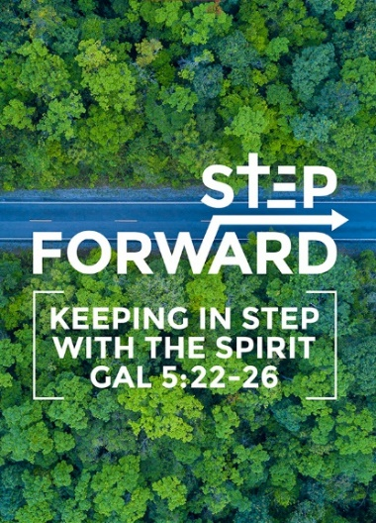
… In A Media-Savvy Age (Romans 12:1-2)
Pastor Terry Yeow
Therefore, I urge you, brothers and sisters, in view of God’s mercy, to offer your bodies as a living sacrifice, holy and pleasing to God—this is your true and proper worship. Do not conform to the pattern of this world, but be transformed by the renewing of your mind. Then you will be able to test and approve what God’s will is—his good, pleasing and perfect will. (Romans 12:1-2)

Introduction

‘Media’ is not something new. It has always been used to convey a message. It is just that the main form of media keeps changing throughout time. Here are some examples of media used.

- Letters: This is a form of media that is being used less and less. It was very commonly used in Biblical New Testament times. Many of the books of the New Testament were actually letters written by the apostles.
- Stage plays/theatricals: This is a Medieval times form of media. The plays were based on ‘current’ events and news to informe the people on what was going on. For example, of a King who got married or had a child, of a battle that has been won, etc. It was like CNN and HBO put together.

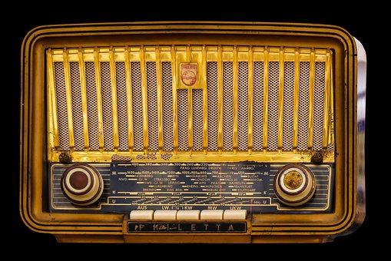
- Public speaking / preaching: This was also commonly used during the Biblical New Testament times. People would go to place where other people would gather and then just start to speak in public.

- Radio: With the start of technology, the radio was created and millions of people could be reached as the same time. People could now listen to current events, news and be entertained right from the comfort of their homes.

- Television: With Television, we now could see as well as hear. Like the radio, millions of people from far and wide could be reached. Media went global as televisions became common place. People here in Malaysia were influenced by the culture of what they saw on television. Many of us watched shows like ‘Happy Days’ and ‘Saturday Night Fever’; we began to emulate and styling ourselves after the characters in the show.

- Social Media: Now in this present age, Social Media has replaced all forms of media. People hardly write letters now. It is very powerful and has impacted everyone, young or old, in one form or another. It has changed the way we do things and get information.

Romans 12:1
Therefore, I urge you, brothers and sisters, in view of God’s mercy, to offer your bodies as a living sacrifice, holy and pleasing to God—this is your true and proper worship.

The word ‘Therefore’ normally refers to something that was previously said. Here it is referring to Romans chapter 1 – 11, which says in summary, “you have been justified by faith”, “you have access to God”, “He is the Hope of Heaven”, “you are shaped by your trials and tribulations”, “there is an overflowing grace of God”, “the Holy Spirit living inside of you” and “Jews or Gentile, you have God’s great promise”. This is bannered by the phrase ‘God’s Mercy’ here in this verse.
‘Living Sacrifice’ - the original Greek word for ‘sacrifice’ is the word that refers to animal sacrifice in the Old Testament. They had to sacrificed animals for their sins and to seek God’s sanctification in order for God’s presence to remain with them.

It is only in God’s presence that we can have salvation, redemption, freedom from bondages, miracles and healing. That is why we need God’s presence in our lives.

- Seek after sanctification and holiness.
- So that He may be ever present in your life.

Romans 12:2a
Do not conform to the pattern of this world, but be transformed by the renewing of your mind. Then you will be able to test and approve what God’s will is—his good, pleasing and perfect will.

‘Do not Conform’ – In order to conform to anything, we must first be formless, structureless, shapeless, without any distinct identity of our own.

We must not let the world squeeze us into the values of the world. With Christ, we have a purpose and identity. Do not give up this identity in Christ for the world’s identity.

‘But be transformed’ – Greek word is ‘metamorphousthe’ meaning a process of maturing.
- Example is how a Caterpillar turns into a Butterfly. There is no such thing of an instant Butterfly.
- The structure of this sentence means that someone or something else is doing the transforming. Thus, it is God who is doing the transformation. It is transformation to spiritual maturity.

Romans 12:2b
Do not conform to the pattern of this world, but be transformed by the renewing of your mind. Then you will be able to test and approve what God’s will is—his good, pleasing and perfect will.

- So that you can prove in PRACTICE that the plan of God for you is GOOD, it meets all of His demands and it moves you towards the goal of MATURITY.
Paul is saying when we surrender our live as a living sacrifice to God, we will carry His presence wherever we go. Because we now carry and identity and purpose in Him, do not allow the world to conform us into its principles, identity and values but instead allow God to transform our lives from within towards spiritual maturity. So that we can prove by how we live our lives that God is good and His plans and purpose for our lives is GOOD.

Present yourself to God as a living sacrifice, surrender to Him. So that you may live in His identity, calling and purpose for you. Be vary of not giving up this identity and conforming to worldly values. Allow Him to begin the transforming process of your life, to be spiritually matured. Thus, being more sensitive to His calling and His direction. So that you may Glorify Him with the way that you live your life.

What does this have to do with living in this media-savvy age?
Here are examples of some people have been used by God throughout the ages, to practice and prove that God is good and amazing through media
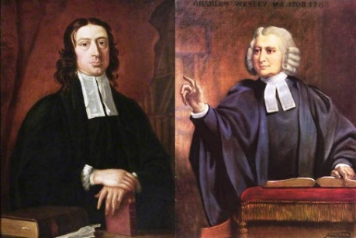
- John and Charles Wesley – founder of Methodist Church
John was inspired by Georgy Whitefield who was conducting public preaching. In those days preaching was done only in the church. Both John and Charles Wesley went around conducting public preaching. Charles wrote songs (teachings) and put them to music that was used in the pubs, music that was familiar to the common people.

- Aimee Semple McPherson – founder of Foursquare Church
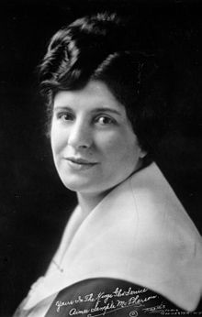
She was extravagant, flamboyant and creative in the way she shared the gospel. One example of her methods was that she would go to a busy street and shout to get the attention of the people, telling them she had something important to say and then tell them to follow her. She would then run towards her church and disappear inside. When the people entered the church, the ushers would lock the doors behind them. There in front of everyone on the stage would be a 500-piece orchestra. They would begin to play worship songs and before the end, Aimee would reappear, all dressed up and come on stage for the climax. This would then be followed by her preaching.

- Bobby Gruenewald – founder of You Version app.
Bobby wanted to impact the masses for God and he started with building a website but within a few months it was a failure. Then one day while standing in a queue in the airport, he noticed that everyone was using a mobile device. This inspired him to build a Bible mobile app, so that people everywhere can have access to the Bible. His mission is to make the Word of God accessible in every language in the world.

These people surrendered their lives to God and allow God to transform and use them.

Conclusion

- Who are we following today – Jesus or this media world?
- Are you conformed to the values of the world?
- Is your identity based on how many likes you get on Facebook, how many followers you have in Twitter or the amount you have in your bank account?
- Would you surrender your life to God and allow Him to begin the process of transformation in your life?
- Would you surrender your attachments to things of this world to things of God?

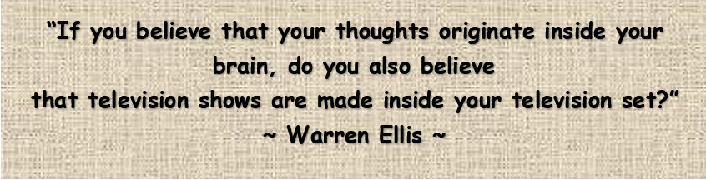

Sermon summary by Prudence

