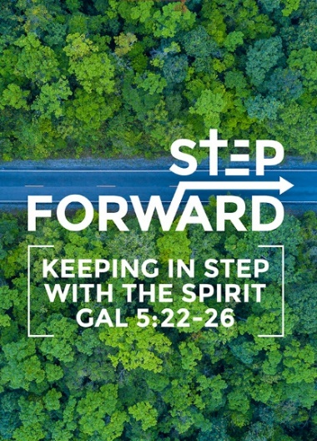
Following Jesus in the Face of Persecution
(Mark 8:34-38)
Senior Pastor Chris Kam

Then he called the crowd to him along with his disciples and said: “Whoever wants to be my disciple must deny themselves and take up their cross and follow me. For whoever wants to save their life will lose it, but whoever loses their life for me and for the gospel will save it. What good is it for someone to gain the whole world, yet forfeit their soul? Or what can anyone give in exchange for their soul? If anyone is ashamed of me and my words in this adulterous and sinful generation, the Son of Man will be ashamed of them when he comes in his Father’s glory with the holy angels.” (Mark 8:34-38)

What kind of person do you want your child to grow up to be? As Christian parents, what kind of Christian do you want your child to become?

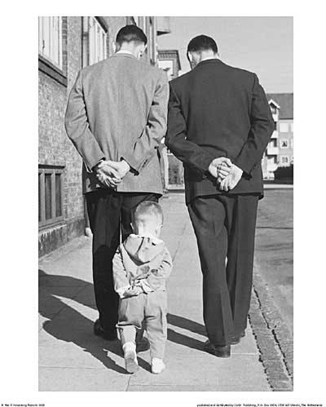
What a child sees, he will do. More is caught than taught. In DUMC, our tagline is ‘love God, serve people, make disciples towards Christ-likeness’. We should help our child to be more like Jesus. We need to grow to be more like Jesus, so that our children can grow to be more like Jesus.

Are there something in our lives worth reproducing? Are we intentional? Otherwise, we produce pseudo-Christians. Pastor Chris coined two terms: one – ‘parking spot Christianity’; that sometimes the greatest spiritual rejoicing comes from when we prayed for a parking spot, and we get a parking spot. Christian life is more than that. Two – ‘paper cut Christianity’; with a paper cut in our lives, sometimes we want to give up already. Are these the types of Christians that we are producing in church?

We have a clear theology of blessing. We must also have a clear theology of suffering. There is a cost to following Christ. There is an even greater reward to the cost of following Christ.

Sometimes things can get really comfortable for us that we forget that there is a cost to following Christ.

The Cost of Being a Disciple (Luke 14:25-33)

Large crowds were traveling with Jesus, and turning to them he said: “If anyone comes to me and does not hate father and mother, wife and children, brothers and sisters—yes, even their own life—such a person cannot be my disciple. And whoever does not carry their cross and follow me cannot be my disciple. “Suppose one of you wants to build a tower. Won’t you first sit down and estimate the cost to see if you have enough money to complete it? For if you lay the foundation and are not able to finish it, everyone who sees it will ridicule you, saying, ‘This person began to build and wasn’t able to finish.’ “Or suppose a king is about to go to war against another king. Won’t he first sit down and consider whether he is able with ten thousand men to oppose the one coming against him with twenty thousand? If he is not able, he will send a delegation while the other is still a long way off and will ask for terms of peace. In the same way, those of you who do not give up everything you have cannot be my disciples. (Luke 14:25-33)

Jesus is not asking you to hate your father and mother. He is saying that in your love for Him compared to your love for your father, mother, children etc, it’s like hate. We need to love Jesus very intensely.

BIG IDEA
Following Jesus is going to cost you!

In fathering our children, we are not going to bring up cushy Christians, that everything they do is for themselves. At the end of the day, are we bringing up children to follow Christ?

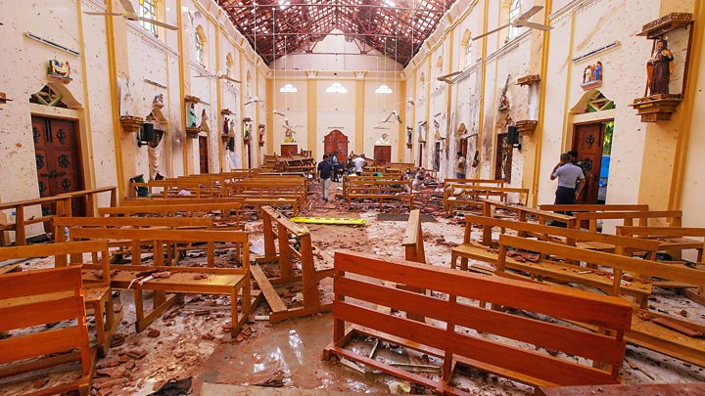
In Easter 2019, we received the sad news of the church bombings in Sri Lanka, where 200 people died and no less than 500 people were injuried. People felt that churches need to take security measures. However, churches are public houses of worship. If people see that such security measures are taken, they will be worried. The last thing we want is to create unnecessary fear.

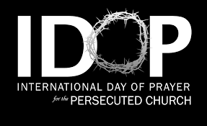
All throughout church history, the killing of Christians are not isolated. What is more sad is that the media is silent. We need to pray. Once a year, we are reminded of these, and there is an International Day of Prayer for the Persecuted Church. Churches around the world remember the persecuted church on this day. This year, it will be held on 23 November 2019.

The last thing we need is to be fearful when we hear of such news. That is why it is important to go into the Word of God.

Jesus said, “If you hold to my teaching, you are really my disciples. Then you will know the truth, and the truth will set you free.” (John 8:31-32)

If we understand the theology of suffering, it will set us free from the fear, anxiety.

The question then is, how then do we count the cost of being a Christian?

Then he called the crowd to him along with his disciples and said: “Whoever wants to be my disciple must deny themselves and take up their cross and follow me. For whoever wants to save their life will lose it, but whoever loses their life for me and for the gospel will save it. (Mark 8:34-35)

Then he called the crowd to him along with his disciples and said: “Whoever wants to be my disciple must deny themselves and take up their cross and follow me. (Mark 8:34)

In the above verse, there are four active verbs: wants, deny, take up, follow.

Mark 8:34

Wants – “Whoever wants to be my disciples…”

When we want to become Christians, there is an invitation given to us. No one in this room is forced to become a Christian. The hallmark of the Christian faith is love, where we have a choice to follow Jesus as our Master. Our children must come to the point where they themselves say that they want to follow Jesus. They cannot follow Jesus by being dependent on their parents.

What does baptism mean? You go into the water; you die, buried with Jesus, and then raised up in the resurrection of Jesus as a new man. Every right to your life died in that water. It is Christ who now lives in you.

Deny – “must deny themselves”

This is not about denying your personality. Your personality remains the same. But God will begin a new work in you. It is not about having more or less. This simply means denying the idolatry of self-centredness.

During Watch Night services, we pray the following covenant:

Annual Methodist Covenant Renewal Service
I am no longer my own but yours.
…
put me to doing, put me to suffering;
…
let me have all things, let me have nothing;
…
I freely and wholeheartedly yield all things to your pleasure and disposal.

The Christian faith is not about “me”; it is about God, about people.

A book has recently been published on Pastor Raymond Koh. Proceeds from this book will be channeled towards a trust fund for his family. This is a reminder that there is a cost to following Jesus.
We must live our lives in such a way that we must not be crippled by fear. We must deny ourselves as it is about God and how He will use me for His kingdom.

Take up – “take up their cross”

When Jesus took up the cross, He did it willingly. He carried the cross of the enemy who wanted to kill Him. He carried it to the place where He died for us in obedience and submission.

You will be hated by everyone because of me, but the one who stands firm to the end will be saved. (Matthew 10:22)

The moment you became a Christian, it’s like telling the world to hate you, point a gun at you and shoot you. Jesus said that the world will hate you because they hated Him in the first place.

Dear friends, do not be surprised at the fiery ordeal that has come on you to test you, as though something strange were happening to you. (1 Peter 4:12)

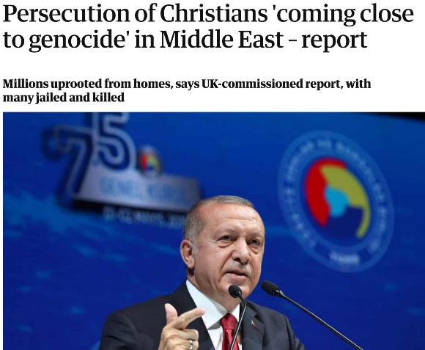
Christians are being crucified everywhere.

“I have told you these things, so that in me you may have peace. In this world you will have trouble. But take heart! I have overcome the world.” (John 16:33)

A research conducted found that 70 million people have died for their faith, for not rejecting Jesus.

A report by The Guardian in May 2019 found that the persecutions of Christians are ‘coming close to genocide’ in the Middle East.

Follow Me – “and follow me”

Follow – (Present imperative in Greek)
“Keep on following me.”

It is not a one-time event where you pray for Jesus to come into your heart. You follow Him until the day you die.
I want to know Christ—yes, to know the power of his resurrection and participation in his sufferings, becoming like him in his death, (Philippians 3:10)

The idea of following Jesus is: all or nothing. There is no halfway. Be hot or cold, not lukewarm.

These questions are asked before one goes for baptism:
- Are you willing to die for your faith?
- Are you willing to go to jail for your faith?
- Are you willing to lose your job for your faith?
- Are you willing to be kicked out by your family for your faith?
- Are you willing to go to rehabilitation camp for your faith?
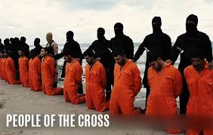
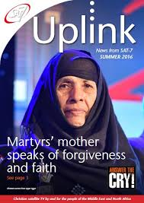
SAT-7 is a Christian satellite television network reaching out to the Middle Eastern countries. In one of their programmes, a man called in, identifying himself as the brother of two, among 21, of the Egyptian Coptic Christians who were beheaded.
It was revealed that they have a mother, as pictured above. She is Mrs Isis Ghattas Dawood – mother of Egyptian Coptic Christians Bisoy and Samuel Estafanus Kamel - two of the 21 beheaded on a Libyan beach in February 2015 by IS.

A video broadcasted by SAT-7 showed an interview with her, concerning the killings of her sons, and how she was honoured for her faith and forgiveness in the face of the tragedy. (Link: https://www.youtube.com/watch?v=uOOdOrE9Z6E&t=77s)

When we are followers of Jesus, are we prepared to pay the cost? How did Mrs Isis Ghattas Dawood raise such children, that at gunpoint, went on to say in their dying breath that Jesus Christ is Lord?

It was later revealed that of the 21, there was a Ghana native who was not a Christian. Just moments before he died, one of the militants asked him if he rejects Christ, to which he answered: ‘their God is my God’. He decided to be a follower of Jesus!

If we say we are Christians, we cannot stay middle ground.

But rejoice inasmuch as you participate in the sufferings of Christ, so that you may be overjoyed when his glory is revealed. (1 Peter 4:13)

What is more, I consider everything a loss because of the surpassing worth of knowing Christ Jesus my Lord, for whose sake I have lost all things. I consider them garbage, that I may gain Christ. (Philippians 3:8)

What is the Holy Spirit saying to you now?

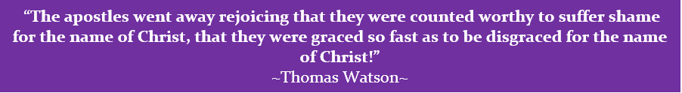

Sermon summary by May

