The Gospel is for Others (2 Corinthians 5:15 – 21)
Pastor Michael Ngui

And he died for all, that those who live should no longer live for themselves but for him who died for them and was raised again. So from now on we regard no one from a worldly point of view. Though we once regarded Christ in this way, we do so no longer. Therefore, if anyone is in Christ, the new creation has come: The old has gone, the new is here! All this is from God, who reconciled us to himself through Christ and gave us the ministry of reconciliation: that God was reconciling the world to himself in Christ, not counting people’s sins against them. And he has committed to us the message of reconciliation. We are therefore Christ’s ambassadors, as though God were making his appeal through us. We implore you on Christ’s behalf: Be reconciled to God. God made him who had no sin to be sin for us, so that in him we might become the righteousness of God. (2 Corinthians 5: 15-21)

Introduction

This sermon is the fourth in the Gospel series. To recap, the first three sermons were:
- The Gospel is for All of life
  - The Gospel is the “A-to-Z” of the Christian life
- The Gospel is for Salvation
  - God saves sinners through Christ
- The Gospel is for Growth
  - The Gospel grows and matures you to be more Christ-like

This week, the message is about the Gospel changes one’s orientation towards the world

BIG IDEA: The Gospel inspires us toward others

A narcissist is a person who has an excessive interest in or admiration of themselves. The word “narcissist” comes from Greek mythology. Narcissus was a man known for his beauty and would admire reflections of himself. One day, he chanced upon a still lake, and as he went nearer and nearer into his own reflection, he fell into the lake and drowned. The story illustrates that to love oneself in excess is to destroy oneself. It shows that fleshly beings as us need to be saved from our self-ruling, self-absorbed ways. Through Christ we are to change our orientation from self-focused to God-focused, allowing ourselves to be matured into Christlikeness and see other’s needs – both current and eternal.

Proclaim the Good News
- Through word of mouth in everyday settings.
“Therefore go and make disciples of all nations, baptizing them in the name of the Father and of the Son and of the Holy Spirit, and teaching them to obey everything I have commanded you. And surely I am with you always, to the very end of the age.” (Matthew 28: 19-20)

All this is from God, who reconciled us to himself through Christ and gave us the ministry of reconciliation: that God was reconciling the world to himself in Christ, not counting people’s sins against them. And he has committed to us the message of reconciliation. (2 Corinthians 5: 18-19)

Jesus gave a mission to all Christians: the ministry of reconciliation. Proclamation of the Gospel is not just for those at the pulpit, but it is the Good News that can and should be proclaimed every day.

We tell because we have experienced His love and goodness

Since, then, we know what it is to fear the Lord, we try to persuade others. What we are is plain to God, and I hope it is also plain to your conscience… For Christ’s love compels us, because we are convinced that one died for all, and therefore all died. (2 Corinthians 5: 11, 14)

But in your hearts revere Christ as Lord. Always be prepared to give an answer to everyone who asks you to give the reason for the hope that you have. But do this with gentleness and respect (1 Peter 3:15)

As marketing guru Philip Kotler says, “The best advertising is done by satisfied customers.” We tell others about God based on what we have experienced and know of. If we lack the words, perhaps it is our apprehension of Him is too shallow therefore have nothing to say when asked about our faith. If we find ourselves in that situation, this is a wake-up call to read and understand the word of God to know and be able to present the reason of your faith.

The Gospel is too good to keep to ourselves. We need not be the best speakers, but to raise the flag as an opportunity for others to get curious and want to hear about the Gospel, through Christ’s transformative work in our lives.

Portray the Good News
- Through good works in your everyday settings
So we make it our goal to please him, whether we are at home in the body or away from it. 10 For we must all appear before the judgment seat of Christ, so that each of us may receive what is due us for the things done while in the body, whether good or bad. (2 Corinthians 5: 9-10)

We will answer to Christ for what we do
Are we bearer of Good News? Are we different in a good way? Good works marks God’s salvation in our lives to others.

For it is by grace you have been saved, through faith—and this is not from yourselves, it is the gift of God— not by works, so that no one can boast. For we are God’s handiwork, created in Christ Jesus to do good works, which God prepared in advance for us to do. (Ephesians 2: 8-10)

We are to do what is good
Doing good is a feature in the life of a disciple. It is not just about reading the Bible, attending church and cell group meetings, praying and tithing. It is about being a good and morally upright in all aspects and circumstances of our lives.

This is a trustworthy saying. And I want you to stress these things, so that those who have trusted in God may be careful to devote themselves to doing what is good. These things are excellent and profitable for everyone. (Titus 3:8)

God saved us through Christ to do good works
Wherever we may be – at home, workplace, classroom, community – we are to do good. Good works in our everyday lives are to be shown as God’s masterpieces. By allowing God to change us, we are giving praises to Him.
For we are his workmanship, created in Christ Jesus for good works, which God prepared beforehand, that we should walk in them. (Ephesians 2: 10 English Standard Version)

We are saved to do good works
As part of a test, a teacher of the law asked Jesus “who is my neighbour?” to which Jesus replied using the parable of the Good Samaritan (Luke 10: 25 -37). To inherit eternal life, we are to be genuinely good even when there is no one to witness our good works. Serving the needy around us it is not about showing off. Rather, it is about being a child of God.

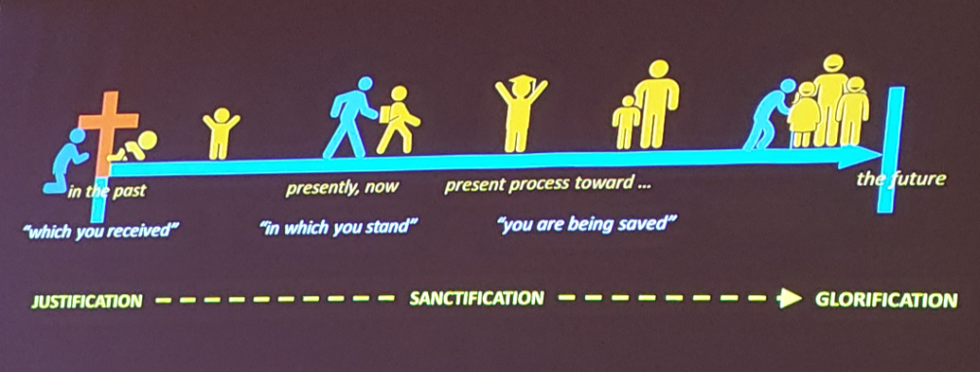
Prove the Good News
- Though your walk with God in your everyday settings
Prove to yourself that your life changed through salvation in Christ is good, by growing and maturing into Christlikeness.

Training in Righteousness
Being good is not an overnight transformation. It takes effort; a disciplined regimen to build up.
Have nothing to do with godless myths and old wives’ tales; rather, train yourself to be godly. For physical training is of some value, but godliness has value for all things, holding promise for both the present life and the life to come. (1 Timothy 4: 7-8)

All Scripture is God-breathed and is useful for teaching, rebuking, correcting and training in righteousness, so that the servant of God may be thoroughly equipped for every good work (2 Timothy 3:16-17)

But solid food is for the mature, who by constant use have trained themselves to distinguish good from evil. (Hebrews 5:14)

Jesus pays attention to the heart
Years of being a Christian does not equate to a mature Christian. It takes “Heart Training” for one to become mature in Christ.
But I tell you that anyone who looks at a woman lustfully has already committed adultery with her in his heart. (Matthew 5:28)

But I know you. I know that you do not have the love of God in your hearts. (John 5:42)
A good man brings good things out of the good stored up in his heart, and an evil man brings evil things out of the evil stored up in his heart. For the mouth speaks what the heart is full of. (Luke 6:45)

Pay attention to the heart because God sees the heart. The heart is where it all begins. If we want change to happen, we must allow God to change our hearts and let it become more like His.

Here I am! I stand at the door and knock. If anyone hears my voice and opens the door, I will come in and eat with that person, and they with me. (Revelation 3:20)
The context of Revelations 3: 14 – 20 is addressed to the church in Laodicea, which was described as lukewarm in their work, and God was not pleased with them as they are busy doing things but their hearts were not right with God. Jesus calls out to them to let Him into the doors of their hearts and have fellowship with Him.

Are there areas in our lives that are not open to God? Those inaccessible areas are what stop us from being fully transformed in Christ and to effectively do His works. Until and unless we open every aspect of our lives to Him, we cannot be truly transformed.

In closing…
The Good News must change our hearts and change our focus to God, making our heart conditions to be aware to the needs of those around us, as well as beacons to prepare and attract others to hear the Good News.

Sermon summary by Adeliyn.

