Are you the One?
Jose Philip
John’s disciples told him about all these things. Calling two of them, he sent them to the Lord to ask, “Are you the one who is to come, or should we expect someone else?” When the men came to Jesus, they said, “John the Baptist sent us to you to ask, ‘Are you the one who is to come, or should we expect someone else?’” (Luke 7:18-20)

Introduction
Everyone wants to ask questions and they want their questions to be answered. All of us, at some point in time, in whatever shape or form of the question, have reached out to someone else and asked, “Are you going to be the one who is going to help me?”

It is common experience that the one we have looked to for help and support has invariably let us down. What happens when the heart is grappling between a question we really want to ask and an experience that compels us to push the question away? Often, we use the word ‘doubt’ to describe that experience. We desperately want to ask the question, but we don’t want to hear the answer, for we are afraid lest it let us down.

John the Baptist

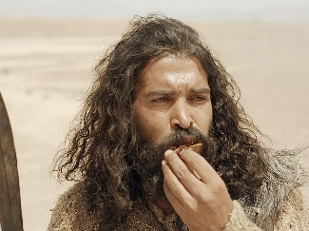
John the Baptist was an uncommon person, not just in the village he grew up in, but in the times he grew up. John’s birth was prophesied. It was a gift to be given to the people, to prepare the way for God’s ultimate gift. He grew up wearing strange clothes and eating strange food. He breaks into the public scene, saying, “Repent! For the Kingdom of God is at hand.” Those were literally his first words.

John had an uncommon vision and clarity about what God was going to do. No one expected him to say what he was saying, but the people were excited, gathering around him. John was like a magnet, drawing people to himself. However, he was not pointing the attention to himself, instead he pointed to Jesus, calling Him the Lamb of God. He was the voice thundering in clarity when silence has been the people’s experience for hundreds of years.

When John was in prison, he heard about what Jesus had been doing, and he sends his disciples to Jesus, asking, “Are you the one, or should we look for another?” Disappointment, unfortunately, is part of the life we experience, and nothing disappoints us more than being disappointed with God. Thankfully, God is not silent, nor is the Word of God incapable of dealing with our disappointments.

John’s disciples told him about all these things. Calling two of them, he sent them to the Lord to ask, “Are you the one who is to come, or should we expect someone else?” When the men came to Jesus, they said, “John the Baptist sent us to you to ask, ‘Are you the one who is to come, or should we expect someone else?’” (Luke 7:18-20)

The Centurion

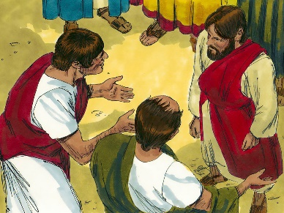
Jesus was going on His way when friends of a centurion came to Him, one who was well regarded in the community and had a hundred soldiers under him. The centurion’s servant was not well, and the people around Jesus were commending all the good works the centurion has done for them, and how he deserves Jesus’ help. The centurion finds a way to get to Jesus and he said something fascinating to Jesus, “Lord, don’t trouble yourself, for I do not deserve to have you come under my roof. That is why I did not even consider myself worthy to come to you. But say the word, and my servant will be healed. For I myself am a man under authority, with soldiers under me. I tell this one, ‘Go,’ and he goes; and that one, ‘Come,’ and he comes. I say to my servant, ‘Do this,’ and he does it.”” Jesus was amazed to hear this, and said to the crowd following him, “I tell you, I have not found such great faith even in Israel.” The men who had been sent to Jesus returned to the house to find the servant healed.

So Jesus went with them. He was not far from the house when the centurion sent friends to say to him: “Lord, don’t trouble yourself, for I do not deserve to have you come under my roof. That is why I did not even consider myself worthy to come to you. But say the word, and my servant will be healed. For I myself am a man under authority, with soldiers under me. I tell this one, ‘Go,’ and he goes; and that one, ‘Come,’ and he comes. I say to my servant, ‘Do this,’ and he does it.” When Jesus heard this, he was amazed at him, and turning to the crowd following him, he said, “I tell you, I have not found such great faith even in Israel.” Then the men who had been sent returned to the house and found the servant well. (Luke 7:6-10)

The Widow

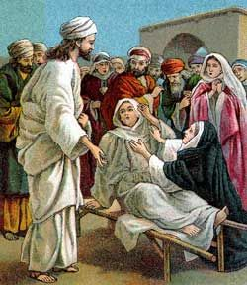
Jesus went along to a town called Nain, where there was a funeral procession. It was a tragic scene, for a widow’s only son was being carried out the town gate. She had lost her husband, and now the only other person who could take care of her, her son, was dead too. This was tragedy pressed down beyond belief. Jesus goes and touches the coffin, and brings that man back to life.

Soon afterward, Jesus went to a town called Nain, and his disciples and a large crowd went along with him. As he approached the town gate, a dead person was being carried out—the only son of his mother, and she was a widow. And a large crowd from the town was with her. When the Lord saw her, his heart went out to her and he said, “Don’t cry.” Then he went up and touched the bier they were carrying him on, and the bearers stood still. He said, “Young man, I say to you, get up!” The dead man sat up and began to talk, and Jesus gave him back to his mother. (Luke 7:11-15)

John’s question comes in this context. The disciples of John observed all that was happening, and they had gone to John to tell him what Jesus had been doing. John was in prison at that time, and he told his disciples to ask Jesus if He was the One. John was not asking it from the vantage point that if Jesus was the one, why then is he still in prison. That was not the motive behind the question, for Jesus had commended John and said that there was no one born of a woman who is greater than John.

Sometimes, that is what we grapple with. Often, the disappointments that we have in life is shaped by the expectations we have had of God. Jesus told John’s messengers in reply to the question that John asked Him, “Go back and report to John what you have seen and heard: The blind receive sight, the lame walk, those who have leprosy are cleansed, the deaf hear, the dead are raised, and the good news is proclaimed to the poor.”

At that very time Jesus cured many who had diseases, sicknesses and evil spirits, and gave sight to many who were blind. So he replied to the messengers, “Go back and report to John what you have seen and heard: The blind receive sight, the lame walk, those who have leprosy are cleansed, the deaf hear, the dead are raised, and the good news is proclaimed to the poor. Blessed is anyone who does not stumble on account of me.” (Luke 7:21-23)

The Sinful Woman and Simon the Pharisee

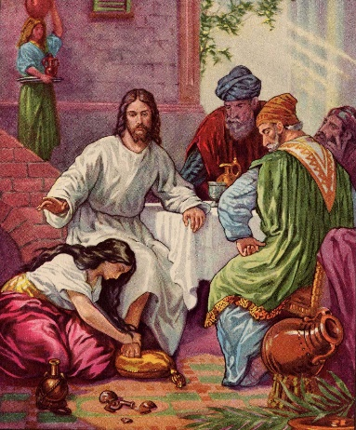
Jesus went to have dinner at the house of Simon the Pharisee. Simon was asking the same question as John the Baptist, but from a different vantage point. John wanted assurance, but Simon was skeptical. A woman, whose name we do not know, but with a reputation of which everyone knows, learned that Jesus was eating at the Pharisee’s house, so she goes there with an alabaster jar of perfume. She wet Jesus’ feet with her tears, wiped them with her hair, kissed them and poured perfume on them. Jesus was sitting reclined on his back, so the woman was literally on her knees.

When one of the Pharisees invited Jesus to have dinner with him, he went to the Pharisee’s house and reclined at the table. A woman in that town who lived a sinful life learned that Jesus was eating at the Pharisee’s house, so she came there with an alabaster jar of perfume. As she stood behind him at his feet weeping, she began to wet his feet with her tears. Then she wiped them with her hair, kissed them and poured perfume on them. (Luke 7:36-38)

Simon the Pharisee was offended by this and said to himself, “If this man were a prophet, he would know who is touching him and what kind of woman she is—that she is a sinner.” The question, in a different shape and form, was the same: “Are you the One?” Simon and John were grappling with the same question. John was in prison and wanted to be assured, but Simon was wondering if he had wasted his time and money on a prophet wannabe.

The centurion wants Jesus to help, but he knows he is undeserving. Many of us desperately want God to help us, but we find ourselves unworthy. The truth of the Gospel is that God is for us even when we do not think we are deserving of it. God is for us, even when we think we are unworthy. Not one of us is worthy of Him, but not one of us is beyond Him.

The widow had no one to go to, no place to turn, and she was deep in grief. She was so weighed down by grief that she could not even utter any words. The beauty of the Gospel is that God is for you, even when you do not know how to ask for help. Jesus is the only one for you, even when you are undeserving of Him. Jesus is the only one for you, even when you do not know how to ask for help. Jesus says, “I am the only one.”

Simon was cynical. In his eyes and in his book, Jesus was disqualified from being a prophet, let alone be the Messiah.

Jesus answered him, “Simon, I have something to tell you. Two people owed money to a certain moneylender. One owed him five hundred denarii, and the other fifty. Neither of them had the money to pay him back, so he forgave the debts of both. Now which of them will love him more?” Simon replied, “I suppose the one who had the bigger debt forgiven.” “You have judged correctly,” Jesus said. Then he turned toward the woman and said to Simon, “Do you see this woman? I came into your house. You did not give me any water for my feet, but she wet my feet with her tears and wiped them with her hair. You did not give me a kiss, but this woman, from the time I entered, has not stopped kissing my feet. You did not put oil on my head, but she has poured perfume on my feet. Therefore, I tell you, her many sins have been forgiven—as her great love has shown. But whoever has been forgiven little loves little.” (Luke 7:40-47)

The centurion was familiar with what Jesus could do, so he asked favors from Jesus and he got it. The woman at Jesus’ feet was more than familiar with what Jesus could do, she knew what forgiveness was. Faith nurtured by familiarity will keep looking for favors, but a faith that is found and nurtured in grace and forgiveness will return forgiveness with love. Jesus says, “I am the only one who knows you as you are and loves you. I love you enough to forgive you.” This is not a forgiveness that is merely lip service saying, “It is ok.” This is a forgiveness that draws you into the open to celebrate that love. Jesus is the only one who freely forgives and is patient with the one who does not understand why He does so.

Simon was not abandoned. Jesus could have brushed Simon off. Jesus healed the sick and raised the dead. He could have looked at Simon, and Simon’s unrepentant heart could have crushed. Jesus was not going to force or manipulate just to compel anyone to see the truth of who He was. Jesus made Himself available so that the one who would come to Him will receive forgiveness, and the one who did not, understand why he was forgiven and what love really is.

If Jesus is not the one, there is no other one for you. If Jesus is not who He claimed Himself to be, love is what we would lose. The only faith and the only worldview that is founded on love, the only God who is described as love, not just someone who loves or expects you to love, is the God of the Bible, and that God so loved the world that He gives us Jesus. He is the one for us, even when we don’t think we are deserving of Him. He is the one for us, even when we do not know how to ask Him for the help that we desperately need. If He had required us to ask of Him, which one of us could be saved? We ask for His forgiveness because He has already offered it to us, and we now have to receive it. There is no other worldview that is founded on love, because there is no other faith that has at its very core, the cross, on which Jesus says, “Father, forgive them.”

If there is no forgiveness, all we have left to offer each other is what Simon offered the sinful woman – ridicule. If there is no forgiveness, we will be constantly ridiculing each other, at loggerheads with each other. There will be no way of being restored to each other, and humanity will lose the one thing that helps us flourish – love. Jesus is the only one who can move us from the desperate stage of loveless-ness that we find ourselves in, which is one word that summarizes the human problem we experience today. Jesus is the only one who can take that loveless-ness away and give to us in return – love.

Conclusion

The question: “Are you the One?” was not just for John to ask, the question was for all of us to ask. The answer was not for John to hear and receive alone, the answer was for all of us to receive and embrace. If Jesus is not the one for us, then who is? Everyone, no matter how old or young, follows someone, emulates someone, models themselves after someone, measures themselves up against someone. If Jesus is not worth following, then who is? If Jesus is not worth entrusting your life to, then who is? If Jesus is not the one worth committing your life to and drawing your life from, then who is? The answer to the question is that there is no one else. He alone is for us, even when we ourselves do not give ourselves a chance. That was what Jesus did for Simon, because He had already done that for the sinful woman. There are many people who invested themselves to help others come to know Jesus, and it comes from a life that has experienced the love of Jesus.

Is Jesus the one in whom you find your life? That was the question that every person in Luke 7 had encountered. It does not matter with what motivation they came to Jesus, Jesus was always prepared to meet them where they were, but Jesus never left them as He found them. He drew them to Himself and showed them what it means to be people who are loved.

Sermon summary contributed by Anthea Tan

