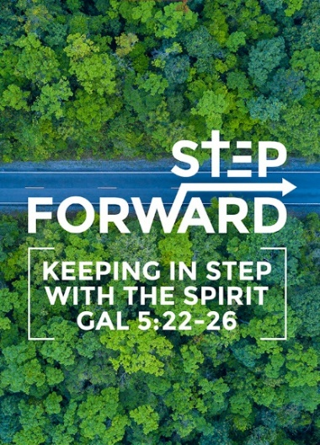
The Mission Heart of God : For the People There
(1 Samuel 22:1,2,5 & Psalm 57:1-2,9,11)
Pastor Ross Winchester

David left Gath and escaped to the cave of Adullam. When his brothers and his father’s household heard about it, they went down to him there. All those who were in distress or in debt or discontented gathered around him, and he became their commander. About four hundred men were with him. But the prophet Gad said to David, “Do not stay in the stronghold. Go into the land of Judah” So David left and went to the forest of Hereth. (1 Samuel 22:1,2,5)

Have mercy on me, for in you I take refuge. I will take refuge in the shadow of your wings until the disaster has passed. I cry out to God Most High, to God, who fulfils his purpose for me. (Psalm57:1-2NLT)

I will thank you, Lord, among all the people. I will sing your praises among the nations. Be exalted, O God, above the highest heavens. May your glory shine over all the earth. (Psalm57:9,11NLT)

BIG IDEA
There are 3 Ι‘s, i.e. Identification , Influence and Impact.

Introduction
You cannot have Impact without Influence and you cannot have Influence without Identification. Ministry starts when we Identify People who have problems, distressed, in debt, discontented, grumblers, etc. All those who were in distress or in debt or discontented gathered around him, and he became their commander. (1 Samuel 22:2)

God wants to take the little we have to transform the world.

The Question we need to ask ourselves :
Do we have a CAVE (Comfortable And Very Exclusive) OR a COMMUNITY mentality?

The GREAT COMMISSION requires us to determine whether we are reaching out beyond our immediate environment, reaching community through the nations bringing closure to the Great Commission.

3 steps we need to take in order to transform the world for Christ, Identification, Influence, and Impact.

Identification
What is the difference between UNSAVED and UNREACHED?

Unsaved are those within the reach of the Gospel message but have chosen not to respond. We continue to minister in their lives and to show the love of Christ in all circumstances.

Unreached are those who never had the opportunity to hear any presentation of the Gospel. Half the world still has not heard of the first coming of Christ while the Church is already waiting for His second coming. We need to leave the comfortable lifestyle and be with them to share their life in order to be able to touch them like Jesus did.

Jesus broke down cultural, geographic & religious barriers by talking about a common element -
Water. The Jews may live high on the mountain while the Samaritan live in the lowlands, yet all
come by to draw Water at the same place.

So, the challenge is to identify without losing our identity; start building relationship through a common interest, plan and strategize.

“Why should anyone hear the Gospel twice, before everyone has heard it once?” ~Oswald J Smith

“Any church that is not seriously involved in helping fulfill the Great Commission has forfeited its biblical right to exist.” ~Oswald J Smith

Let us not forget the unreached! The Church very nature is inclusive in reaching out to the Unreached. Our mandate is to bring to Christ every man from every nation.

Influence
Our Strategy is: How do we prepare to be fishermen? Three points of fishing philosophies:

Go where the fish are.
Too much of evangelism today looks like fishing in a bathtub. Go to universities, colleges, music festivals, we go into their world to bring Christ to them in their world.

Use the right bait.
It is not about what we like. It is about what the fish likes. It is about what can connect us with people so that we can build the relationship and present the Gospel to them, the people there.

Do not try to ‘clean the fish’ until you have caught it
Do not try to change people with doctrines. Do not try to fix them before they accept Jesus. Jesus welcome the taxpayers, sinners and did not condemn nor try to change them but accept them and forgave them. So that they are won over into the kingdom. Jesus did not come to make bad men good, He came to make dead men alive.

God is our place of refuge. We need to help ourselves first before we can help others. So, we need to be spiritually healthy before we can influence others.

Have mercy on me, for in you I take refuge. I will take refuge in the shadow of your wings until the disaster has passed. (Psalm 57:1)

Impact:
But the prophet Gad said to David, “Do not stay in the stronghold. Go into the land of Judah” So
David left and went to the forest of Hereth. (1Samuel 22:5)

God wants His Glory to be seen and influenced throughout the whole world. Just as the prophet Gad told David to leave his stronghold and go into the land of Judah; so that He want us to leave our comfortable lifestyle and take the step of faith and manifest what God wants to do.

What is His Purpose? That none shall perish. God wants to use us to fulfil His purpose. How?
GO INTO THE WORLD AND IMPACT THE LIVES OF ALL IN THE WORLD.

Our MISSION:
To change the UN-loved to be the LOVED
To change the UN-wanted to be WANTED
To change the UN-cared for to be CARED FOR
To change the UN-believing to the BELIEVING
To change the UN-saved to the SAVED
To change the UN-blessed to be BLESSED
To change the UN-godly to the GODLY
To change the UN-righteous to become the RIGHTEOUSNESS OF GOD

The insidious cycle of pain can be changed through the Will of God ,through His Agape Love;
that made:
- the rescued the Rescuer
- the healed the Healer
- the helped the Helper
- the cared for the Caregiver
- the blessed the Blesser

Conclusion:
When we are in our CAVE we are our place of security and comfort, we only see our own needs.
We need to get out and take the step of faith out to see God’s supernatural power, manifest and do what God’s will.

When we get out of the CAVE, we begin to notice the needs, challenges of people around us.

God has called us to bring SALVATION to the people; we need to leave our CAVE and expand our Influence and so expand our Impact.

So Joshua said to the Israelites: “How long will you wait before you begin to take possession of the land that the LORD, the God of your ancestors, has given YOU? (Joshua 18:3)

Sermon summary by Michelle Chuah

