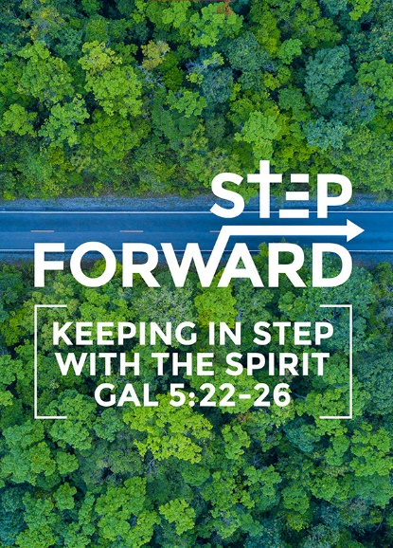
Stepping Forward: A Different Spirit
Pastor Chris Kam
“The Lord replied, “I have forgiven them, as you asked. Nevertheless, as surely as I live and as surely as the glory of the Lord fills the whole earth, not one of those who saw my glory and the signs I performed in Egypt and in the wilderness but who disobeyed me and tested me ten times - not one of them will ever see the land I promised on oath to their ancestors. No one who has treated me with contempt will ever see it. But because my servant Caleb has a different spirit and follows me wholeheartedly, I will bring him into the land he went to, and his descendants will inherit it." (Numbers 14:20-24)

Introduction
What are you grateful for in life, in 2019? What has been unsettling that you are not grateful about?
How can we be thankful of the things that we are not grateful about?
Be real, reflect, write them down and commit those struggles to God. You will find that God has always been there through these times, and you can still be thankful even when you are not okay.

Recap:

There are many who are at different ‘steps’ in their lives, but there is a category of people who have not stepped up at all. They are called the “pew-warmers”.

In the “Stepping Forward” series, there were two characters that have been preached on:

Date | Character | What we learned
21 and 22 Sept 2019 | Gideon | God can use me.
05 and 06 Oct 2019 | Abraham | Step out of our comfort zone.

Are you familiar with these names?

Shammua  Shaphat  Igal  Hoshea  Palti | Gaddiel  Gaddi  Ammiel  Sethur  Nahbi | Caleb  Joshua

All twelve belong to a same group of people in Scripture. There were the twelve young men sent out to scout the Promised Land. What separates Caleb and Joshua from the unfamiliar ten is that they had a Different Spirit.
BIG IDEA: Out of your comfort zone. Embrace a Different Spirit.
The Context:
Numbers 13: 17-20 - Speaks about the mission of the 12 spies.
When Moses sent them to explore Canaan, he said, “Go up through the Negev and on into the hill country. See what the land is like and whether the people who live there are strong or weak, few or many. What kind of land do they live in? Is it good or bad? What kind of towns do they live in? Are they unwalled or fortified? How is the soil? Is it fertile or poor? Are there trees in it or not? Do your best to bring back some of the fruit of the land.” (It was the season for the first ripe grapes.)
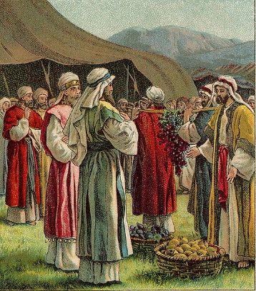
Numbers 13:23, 27 - They find that the land is fertile and fruitful.
When they reached the Valley of Eshkol, they cut off a branch bearing a single cluster of grapes. Two of them carried it on a pole between them, along with some pomegranates and figs. .. They gave Moses this account: “We went into the land to which you sent us, and it does flow with milk and honey! Here is its fruit.

Numbers 13:28-29 - Even though God has said that it is the Promised Land, still the 10 spies emphasized on the “but”. This word gives a negative and discouraging connotation.
But the people who live there are powerful, and the cities are fortified and very large. We even saw descendants of Anak there. The Amalekites live in the Negev; the Hittites, Jebusites and Amorites live in the hill country; and the Canaanites live near the sea and along the Jordan.”

In Ancient Greece - there were 3 groups of people:
- Idiots - people who were private, self-centered and selfish.
- Tribalists - people who were afraid and suspicious of anyone who are different / alien from them. They resorted to intimation, force and violence to get their way. Xenophobic.
- Citizens - people with critical thinking and work to settle differences for the betterment of society. They have dialogues and discussions that cut across barriers in language, culture and background. They also valued friendship.

In today’s times, there are similar groups of people - whether in our country, or our church.
We have to learn to stop saying, “but”. We should have a different spirit.
Be givers, not takers. Be chargers, not dischargers.

Numbers 13:30 - Caleb was confident that “… we can certainly do it.”
Then Caleb silenced the people before Moses and said, “We should go up and take possession of the land, for we can certainly do it.”

All twelves spies saw the same thing, but Caleb and Joshua saw something different from the ten.

Numbers 14:20-24 - Because of the 10 spies, anyone above the age of 19 (except Caleb and Joshua) were not allowed to enter the Promised Land.
The Lord replied, “I have forgiven them, as you asked. Nevertheless, as surely as I live and as surely as the glory of the Lord fills the whole earth, not one of those who saw my glory and the signs I performed in Egypt and in the wilderness but who disobeyed me and tested me ten times— not one of them will ever see the land I promised on oath to their ancestors. No one who has treated me with contempt will ever see it. But because my servant Caleb has a different spirit and follows me wholeheartedly, I will bring him into the land he went to, and his descendants will inherit it.

Numbers 14:24a - stand out as someone who is worthy to be followed. Be holy - stand apart.
But because my servant Caleb

NIV: … has a different spirit
NLT: … has a different attitude
TLB: … is a different kind of man
CEV: … isn’t like the others
ERV: … was different

and follows me wholeheartedly.

What is this “different spirit”?

Purpose-driven

Knew what God had said
God has already said, “I will give it to you.”
“... and said to the entire Israelite assembly, “The land we passed through and explored is exceedingly good. If the Lord is pleased with us, he will lead us into that land, a land flowing with milk and honey, and will give it to us. Only do not rebel against the Lord. And do not be afraid of the people of the land, because we will devour them. Their protection is gone, but the Lord is with us.” (Numbers 14:7-9)

Caleb and Joshua’s confidence was based not in their own abilities, but in the Lord. The other ten did not know this. They were either ignorant or indifferent for God’s promises.

Do you know God’s Word and promises? Do you know what God is saying for 2020? If you do not know, you will live fearful lives. When the “buts” hit you, you would be tossed to the left and right, and fall away.

How then would God speak to you? It could be ordinarily in your quiet time.
You can hear God, when you spend time with God. Do you read the Bible regularly?

Some of us need to press ‘reset’ and start over. Commit to following 2020’s Bible Reading Plan, that emphasizes on “Stop. Listen. Go.” Be purpose driven.

“Once in seven years I burn all my sermons; for it is a shame, if I cannot write better sermons now than I did seven years ago.” ~John Wesley

If we only live in our past glory, it would be a disservice to ourselves. We should be able to live in the current and now, hearing what God has to say to us in recent time, or even today.

Envision God’s purpose in spite of the giants
There will be problems in your life.
“I have told you these things, so that in me you may have peace. In this world you will have trouble. But take heart! I have overcome the world.” (John 16:33)
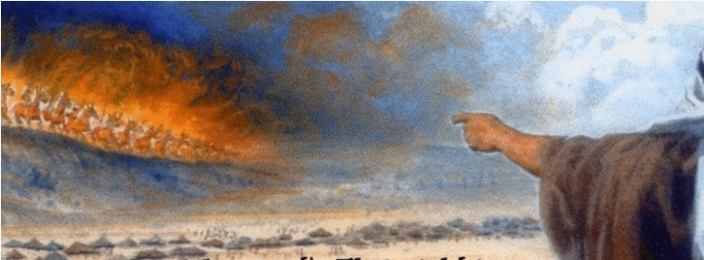
Overcoming the world means having a different spirit. Some things we do not see with the physical eyes. We may be facing a spiritual fight but God is fighting for us.

For example, in the story of Elisha, when he was facing the huge Aramean army, his servant was afraid, but Elisha prayed that the servant would see God’s army.
When the servant of the man of God got up and went out early the next morning, an army with horses and chariots had surrounded the city. “Oh no, my lord! What shall we do?” the servant asked. “Don’t be afraid,” the prophet answered. “Those who are with us are more than those who are with them.” And Elisha prayed, “Open his eyes, Lord, so that he may see.” Then the Lord opened the servant’s eyes, and he looked and saw the hills full of horses and chariots of fire all around Elisha. (2 Kings 6:16)

Positive
The “BUTs” are a lot around us. Examples are
- When we say, “I / We cannot…” with excuses like “no money, talent or skills.”
- When people say, “You cannot…” - when there is no faith-building attitude.
- Worst, when we say, “I will not. I decided to play it safe. Do not rock my boat.”
This is similar to the 10 spies.
Instead, we should say, “I will / want to…”

Then Caleb silenced the people before Moses and said, “We should go up and take possession of the land, for we can certainly do it.” (Numbers 13:30)
Certainly, it was not easy, but the two dared to defy the majority. Know what is right, and do it.
Be positive in the promises of God, not in ourselves

Being positive
- is not about positive thinking (the relying on our own strength) but about ‘possibility thinking’ in God.
- is not great thoughts of us. It is about great thoughts of God.
Be positive in the promises of God, not in ourselves

Do not conform to the pattern of this world, but be transformed by the renewing of your mind. Then you will be able to test and approve what God’s will is—his good, pleasing and perfect will. (Romans 12:2)
God will do the transformation of our minds first. Read the bible then you will know God and His will for you.

The Lord will fight for you; you need only to be still.” (Exodus 14:14)
You only need to avail yourself.

Passionate
Choose to follow God wholeheartedly. Choose to say, “I want or I will…”
“... choose for yourselves this day whom you will serve…. But as for me and my household, we will serve the Lord.“ (Joshua 24:15)
Being passionate is not about what we do in ministry or the things that we do for God.
It is about having a passion for God himself, for the person who died for us and the love that He has shown us.

Conclusion
- Do you know what are the purposes of your life?
- Are you positive about things in 2020?
- Are you passionate and wholeheartedly following God?

Remember, the ten spies caused the entire population to suffer. What we do - our disobedience against God - will have consequences on those around us, be it in our families and children, at our workplace, in cell groups, church or the nation. Let’s be careful with how we live our lives.

In 2020, make:
New Year Resolutions
New Year Obedience
When you walk with God every day, you will have a different spirit.
Ask God, “In what ways can I obey you today?”
You will become a changed person by the end of 2020.
Learn to live in obedience with God.

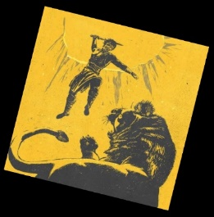
Reminder: Let’s chase our lions!
Hear - Think of something you have never tried
Obey - Do something you have never done
Go - Go somewhere you have never been

That’s the call that God has for us, to have a different spirit, as we enter 2020!

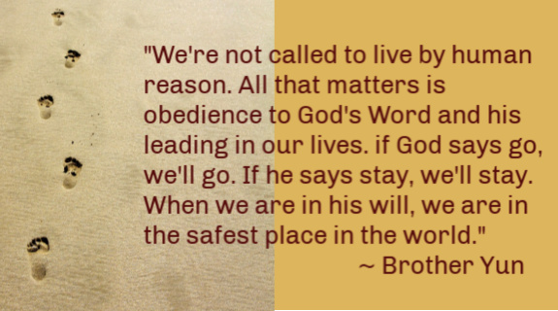

Sermon summary contributed Wendy ML.

