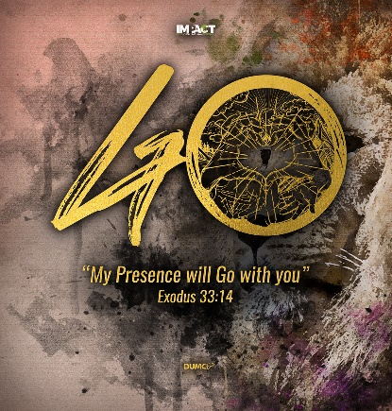
Forward 1 – Don’t Miss Out
(2 Corinthians 9:6-8)
Senior Pastor Chris Kam
Remember this: Whoever sows sparingly will also reap sparingly, and whoever sows generously will also reap generously. Each of you should give what you have decided in your heart to give, not reluctantly or under compulsion, for God loves a cheerful giver. And God is able to bless you abundantly, so that in all things at all times, having all that you need, you will abound in every good work. (2 Corinthians 9:6-8)

Introduction
This sermon is to cast a vision for what is going to happen within this year. The vision for the last 4 years was about helping our people to step:
- 2016 Step Up
- 2017 Step Out
- 2018 Step In
- 2019 Step Forward
This year (IMPACT2020) is the time to be a blessing and impact people by addressing the needs that God is going to show us. It is time for us to step forward and beyond. As we celebrated 40 years anniversary, let us look at the significance of the number 40.

- Moses’ life is divided into 3 segments of 40 years – in each segment, something changed and moved him to something new.
- Moses was on Mount Sinai for 40 days and 40 nights.
- Moses sent spies into the Promised Land for 40 days.
- Jonah warned Nineveh for 40 days.
- Jesus fasted and prayed for 40 days and nights before starting His ministry.
- Jesus appeared to the disciples for 40 days before he ascended to heaven.

40 years is a mark of transition and can represent a generation. In the spiritual, something is going to happen whether personally or in the corporate body for the good of the gospel. God will do something new and powerful in our midst. The Joshua generation will ride on the shoulders of the Moses generation and take the baton to run the next race. The new generation will inherit the Promised Land.

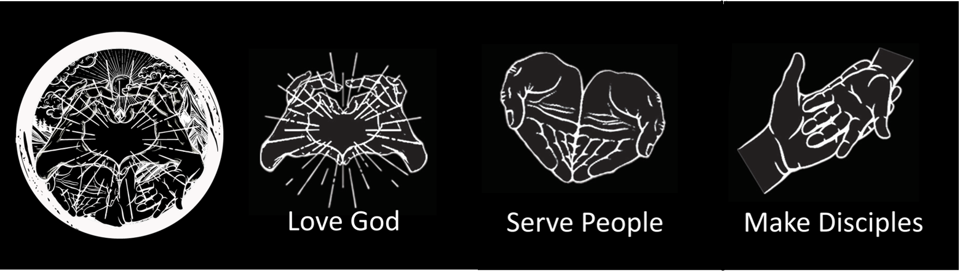
The design on the banner shows both “Go” and “40” which encapsulates the different spirit which we need to have on our 40th anniversary: to go and make an impact. The circle incorporates our tagline with 3 symbols reflecting loving God, serving people and making disciples. We also need to be reminded of our 5 core habits: honour, humility, be real, pass it on, fun.

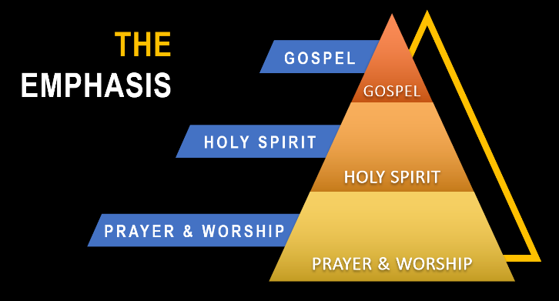
The emphasis should be on preaching the gospel so that we lead people closer to Christ by the power of the Holy Spirit in the atmosphere of prayer and worship.

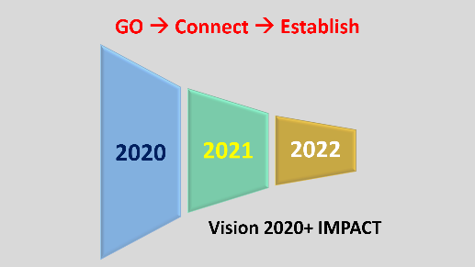
From this year on, we need to think about IMPACT2020. The figure “plus” reminds us that God will challenge us in these 3 years and beyond:

- 2020: Go
- 2021: Connect
- 2022: Establish

You will see the fruits in 3 years’ time. The fruit will be strategic partnership with people with the same heart to establish new ministries. It is about going. God wants us to be a blessing.

The Lord replied, “My Presence will go with you, and I will give you rest.” (Exodus 33:14)
It is not about striving in our own strength but by obeying in faith, we will have rest. When we do IMPACT 2020, it is not about going in our own strength but trusting in the power of the Holy Spirit and standing back to see God working. We need to be dependent on the Holy Spirit.

Let my People Go (From the Past)
Afterward Moses and Aaron went to Pharaoh and said, “This is what the Lord, the God of Israel, says: ‘Let my people go, so that they may hold a festival to me in the wilderness.’” (Exodus 5:1)

We need to move away from the past and things that hinder us. Even God will say to the evil one to let His people go. We need to allow God to let us move forward and have a breakthrough.

- Here am I. Send me! Go… and tell this people (In the Present)
Then I heard the voice of the Lord saying, “Whom shall I send? And who will go for us?” And I said, “Here am I. Send me!” He said, “Go and tell this people: “‘Be ever hearing, but never understanding; be ever seeing, but never perceiving.’ (Isaiah 6:8-9)

- My Presence will go with you (For the Future)
The Lord replied, “My Presence will go with you, and I will give you rest.” (Exodus 33:14)

When they saw him, they worshiped him; but some doubted. Then Jesus came to them and said, “All authority in heaven and on earth has been given to me. Therefore go and make disciples of all nations, baptizing them in the name of the Father and of the Son and of the Holy Spirit, and teaching them to obey everything I have commanded you. And surely I am with you always, to the very end of the age.” (Matthew 28:17-20)

As you decide to go, God is going to be with you. If you do not go, you will not experience the presence of God that is going to be with you. We prefer to be in our comfort zones but God always wants us to be on the move.
So far from 2019…
Gideon – God can use me
Abraham – Step out of your comfort zone
Caleb – Embrace a different spirit

2020 will be an exciting year. Do not do New Year’s resolutions but do New Year’s obedience. As we spend time with God every day, we listen and obey in the different things that God is showing us. Go where God directs you. Even if we are in a state of flux, we can ask God to show us what to do as a journey of faith.
BIG IDEA: This will be a season of sowing. There will come a season of reaping.

When you sow, you cannot see the fruit yet. The soil must be fertile, there must be water and the right conditions. Then you sow. Later there will come a season of reaping. While many of us are unsure what will happen when we go, God reassures us that there will come a season of reaping and we can honestly say we were a part of that. We do not want to have a sense of regret and say we wish we were a part of that. We should be faithful to sow.

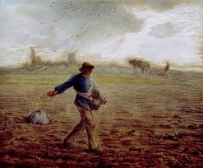
Our Part
Remember this: Whoever sows sparingly will also reap sparingly, and whoever sows generously will also reap generously. (2 Corinthians 9:6)

Our part is to sow. How will you be sowing this year?

The spiritual principle is if you do not sow, you will not reap. You cannot not sow and expect God to bless you. We offer our lives, resources and time to God and ask God to take what He needs to take and we will obey Him in the things that we can do.

Jesus sat down opposite the place where the offerings were put and watched the crowd putting their money into the temple treasury. Many rich people threw in large amounts. But a poor widow came and put in two very small copper coins, worth only a few cents. Calling his disciples to him, Jesus said, “Truly I tell you, this poor widow has put more into the treasury than all the others. They all gave out of their wealth; but she, out of her poverty, put in everything—all she had to live on.” (Mark 12:41-44)

As Jesus looked up, he saw the rich putting their gifts into the temple treasury. He also saw a poor widow put in two very small copper coins. “Truly I tell you,” he said, “this poor widow has put in more than all the others. All these people gave their gifts out of their wealth; but she out of her poverty put in all she had to live on.” (Luke 21:1-4)

It is not about the amount but about your heart. We should sow with open palms and not clenched fists – a posture of surrender and yielding. We offer to the Lord what we have; for example, our talents, our resources, our time or our money. God can take and God can give.

There will never be wealth if you are unwilling to invest. We also need God so that we can invest wisely. People can be fearful of sowing because we are fearful that we will not have enough if we give something away. We may fear that we do not have enough for a rainy day. The flipside of fear is faith. As we learn how to sow, we need to remember even the Macedonian churches were able to give out of their extreme poverty and they will be commended by God. Have faith when you are clear that you are doing what God is telling you to do. Recognise that God owns our lives and creates wealth for us.

You need grace in your life as we are unable to do all this on our own. God gives us grace that we do not deserve if we are willing as long as we step out in faith. You do your part, let God do His part. This is the new year of obedience. We step out in faith as God leads us.

God’s Part
And God is able to bless you abundantly, so that in all things at all times, having all that you need, you will abound in every good work. (2 Corinthians 9:8)

God will bless us abundantly and give us all that we need when we go and sow. There will come a season of reaping – God is doing that, not us.

We should not try to do God’s part. We may have a view of how God should bless us but we must be able to trust that God is in control even if things do not turn out the way we want. Trust that God is able to help us. You do your part and let God do His. Sufficiency is in God and not in ourselves.

I am the vine; you are the branches. If you remain in me and I in you, you will bear much fruit; apart from me you can do nothing. (John 15:5)

But he said to me, “My grace is sufficient for you, for my power is made perfect in weakness.” Therefore I will boast all the more gladly about my weaknesses, so that Christ’s power may rest on me. (2 Corinthians 12:9)

Even in the worst of times, apostle Paul received this word from God – that His grace is sufficient.

Our Posture

Each of you should give what you have decided in your heart to give, not reluctantly or under compulsion, for God loves a cheerful giver. (2 Corinthians 9:7)

This verse is more than about financial giving but also applies to giving of our lives and time to God. We need to make the decision and have a willingness in our lives. When we go, do not give a sour face and be reluctant in doing it. God is serious about people who are lukewarm. We need to be reminded that we need to decide that we want to do it even in our weakness and inability. God is not going to force us to do something against our wills. Do not go under compulsion. We need to go because we want to go. We need to ask God to help us own the vision. We must go cheerfully. There must be joy in giving.

But Samuel replied: “Does the Lord delight in burnt offerings and sacrifices as much as in obeying the Lord? To obey is better than sacrifice, and to heed is better than the fat of rams. (1 Samuel 15:22)

Sacrifice is an obedience from a form compliance rather than wholeheartedly from the heart. God will honour a right posture.

This service that you perform is not only supplying the needs of the Lord’s people but is also overflowing in many expressions of thanks to God. Because of the service by which you have proved yourselves, others will praise God for the obedience that accompanies your confession of the gospel of Christ, and for your generosity in sharing with them and with everyone else. And in their prayers for you their hearts will go out to you, because of the surpassing grace God has given you. Thanks be to God for his indescribable gift! (2 Corinthians 9:12-15)

The love of Christ compels us, not people. Part of giving is in thanksgiving to God. When we learn to sow and give, there is a prayer that comes from the hearts of those who receive, and they give thanks to God for us. That is why when we give, we receive.

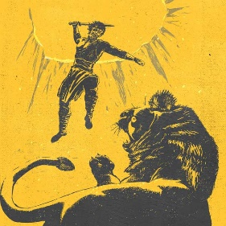
Conclusion

We need to chase the lion and have a dream so big that it is bound to fail if God is not in it. If your dream does not scare you, it is too small.
1. Think of something you have never tried.
2. Do something you have never done.
3. Go somewhere you have never been.

God-sized Dreams
- God-sized dreams ensure our growth.
- God-sized dreams force us to invite others into a bigger story.
- God-sized dreams give glory to Him, not us.

Are we ready? Our lions are in the season of reaping. That is the Lord’s work, not our work. As we have a dream, we need to go out in faith and allow God to use us.
What does IMPACT 2020 mean?
- In our personal life
- In our work life
- In our ministry
- Wherever God places us
Everyone can be involved. Do you want to be involved?

Scope
- Everyone can do
- Most can do
- Only a few can do
Challenge: What is your lion? What is God saying to you?

God is not unjust; he will not forget your work and the love you have shown him as you have helped his people and continue to help them. (Hebrews 6:10)

God will do His part if we do ours. This will be a season of sowing. There will come a season of reaping. Do not miss out!

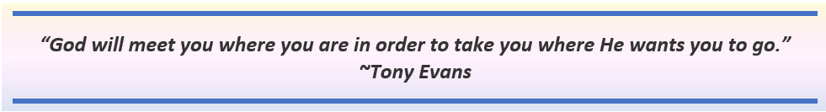

Sermon summary contributed by Zhenli

