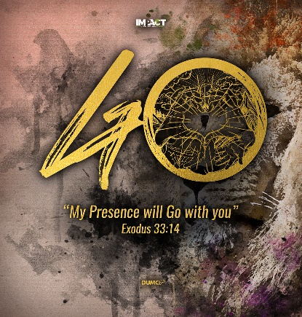
Live out Loud for Jesus!
(Mathew 28:18-20, Acts:1-8)
Pastor Andrias Pantauw

Then Jesus came to them and said, “All authority in heaven and on earth has been given to me. Therefore, go and make disciples of all nations, baptizing them in the name of the Father and of the Son and of the Holy Spirit, and teaching them to obey everything I have commanded you. And surely I am with you always, to the very end of the age.” (Mathew 28:18-20)

But you will receive power when the Holy Spirit comes on you; and you will be my witnesses in Jerusalem, and in all Judea and Samaria, and to the ends of the earth. (Acts 1:8)

Introduction
Pastor Andrias, had been praying for the past 4-6 weeks for good health to enable him to be allowed entry into Malaysia, prior to coming for IMPACT 2020. He. together with his Indonesian church members have been praying against all hindrances before their departure and also for His protection throughout the visit to Malaysia. He stands to testify of God’s faithfulness and control in everything ever since arriving here.

But you will receive power when the Holy Spirit comes on you; and you will be my witnesses in Jerusalem, and in all Judea and Samaria, and to the ends of the earth. (Acts 1:8)

BIG IDEA:
The Mission field is like a playground and a battlefield for us to offer ourselves as useful vessels to share His Love, in living our faith out loud and make disciples of all people groups.

God’s People Must Overcome:
- FEAR of persecution, of death and ashamed of being mocked like Jesus.
- FORGETTING His Promises, Plan and His Commission to be His witnesses to the ends of the earth
- FORGETTING to read His Word which is All Powerful and do not live out lives according to His Word.
Teach us to number our days, that we may gain a heart of wisdom. (Psalm 90:12)

God’s People Need to Grow in His Word
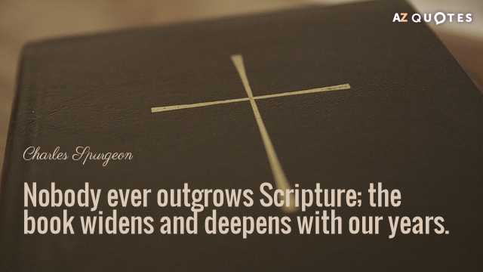
In order for us to GROW we need to equip ourselves with His Word which is eternal, powerful and convicting our hearts giving peace; a solution to our challenges, we need to read His Word which Remove our fears.

But you are a chosen people, a royal priesthood, a holy nation, God’s special possession, that you may declare the praises of Him who called you out of darkness into his wonderful light. (1 Peter 2:9)

God’s People Need to Obey
In order for us to do His Will, we need to pray and ask God how to share with others in our neighbourhood, use of modern apps like You version app which is free to download.

Very truly I tell you, whoever believes in Me will do the works I have been doing, and they will do even greater things than these, because I am going to the Father. (John 14:12 )

God’s People Need to make disciples
In order for us to make disciples we need to encourage those whom we share His Love to seek His Word which will guide them and give them wisdom to share too.

Therefore go and make disciples of all nations, baptizing them in the name of the Father and the Son and the Holy Spirit, and teaching them to obey everything I have commanded you. And surely I am with you always, to the very end of the age. (Matthew 28: 19-20)

Conclusion
Let us avail ourselves despite discomfort, fear and persecution as we obey His Call to Missions.

Go as He calls you for Missions, which is His Greater Kingdom for He is the Lord of the Harvest.

Ask Him to send the Labourers into the Mission field.

And I will do whatever you ask in my name, so that the Father may be glorified in the Son. (John 14:12)

Sermon summary contributed by Michelle Chuah.

