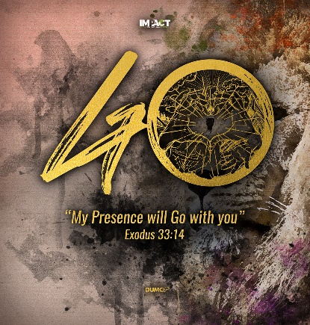
The Church for Such a Time as This
(Psalm 2:1-11; Matthew 24: 1-14)
Pastor Dato’ Dr Daniel Ho, Founding Senior Pastor

Why do the nations conspire and the peoples plot in vain? The kings of the earth rise up and the rulers band together against the Lord and against his anointed, saying,“ Let us break their chains
and throw off their shackles.” The One enthroned in heaven laughs; the Lord scoffs at them. He rebukes them in his anger and terrifies them in his wrath, saying,“ I have installed my king on Zion, my holy mountain.” I will proclaim the Lord’s decree: He said to me, “You are my son; today I have become your father. Ask me, and I will make the nations your inheritance, the ends of the earth your possession. You will break them with a rod of iron; you will dash them to pieces like pottery.” Therefore, you kings, be wise; be warned, you rulers of the earth. Serve the Lord with fear and celebrate his rule with trembling. (Psalm 2:1-11)

Jesus left the temple and was walking away when his disciples came up to him to call his attention to its buildings. “Do you see all these things?” he asked. “Truly I tell you, not one stone here will be left on another; every one will be thrown down.” As Jesus was sitting on the Mount of Olives, the disciples came to him privately. “Tell us,” they said, “when will this happen, and what will be the sign of your coming and of the end of the age?” Jesus answered: “Watch out that no one deceives you. For many will come in my name, claiming, ‘I am the Messiah,’ and will deceive many. You will hear of wars and rumors of wars, but see to it that you are not alarmed. Such things must happen, but the end is still to come. Nation will rise against nation, and kingdom against kingdom. There will be famines and earthquakes in various places. All these are the beginning of birth pains. “Then you will be handed over to be persecuted and put to death, and you will be hated by all nations because of me. At that time many will turn away from the faith and will betray and hate each other, and many false prophets will appear and deceive many people. Because of the increase of wickedness, the love of most will grow cold, but the one who stands firm to the end will be saved. And this gospel of the kingdom will be preached in the whole world as a testimony to all nations, and then the end will come. (Matthew 24:1-14)

Introduction

2019 ended with the Covid-19 infection that affect the whole world and 2020 began with the political turmoil in our nation. Many may feel dismay, but this is not a time of crisis but just a concern. It is a great time and place to live in. You may question why, in today’s sermon, Pastor Daniel will walk us through the bible to explain why it not something new, help us to change our mindset and guide us as to how to respond as church for such a time as this.

The Challenges

At a national level

Conspiracy and compromises
Why do the nations conspire and the peoples plot in vain (Psalms 2:1)
In Malaysia we are seeing conspiracy and compromises taken place in the political parties. There is all kind of sabotages happening within the different camps in politics.

Confusion and consternation
How long, Lord, must I call for help, but you do not listen? Or cry out to you, “Violence!” but you do not save? Why do you make me look at injustice? Why do you tolerate wrongdoing? Destruction and violence are before me; there is strife, and conflict abounds. Therefore the law is paralyzed, and justice never prevails. The wicked hem in the righteous, so that justice is perverted. (cf. Habakkuk 1:2-4)

When there is a political turmoil in our nation, most of us are stumped or dumbfounded or confused. We must not be surprised with what is happening to our nation as it not new. It happened more than 2000 years ago as witnessed in the book of Habakkuk.

Confrontation and coup
The kings of the earth rise up and the rulers band together against the Lord and against his anointed (Psalms 2:2)
We lost stand on the truth, justice and righteousness. Different camps are confronting and fighting one another but all of them are from the wrong camp. Only God’s camp is the right camp.

No compunction
“Let us break their chains and throw off their shackles.” (Psalm 2:3)
There is no feeling of remorse, regret or guilt among those who wrong the nation.

But how do we as Christian are responding? Many of us are upset and angry because of the injustice and unfairness. We are angry with God for not answering our prayers. Pastor. Daniel reminded us that we are seeing things wrongly. God has actually answered our prayers. He is exposing the true nature of the heart of these people. The current Prime Minister has issues appointing his cabinet as he cannot find anyone with integrity to lead the nation. We need to pray for him.

At the global level

Wars and rumours of wars
You will hear of wars and rumours of wars, but see to it that you are not alarmed. Such things must happen, but the end is still to come (Matthew. 24:6) and Nation will rise against nation, and kingdom against kingdom (Mattew. 24:7a)
At the start of the decade, the wars and the rumours of wars fit in perfectly in what Jesus told us in chapter 24 of book of Matthew. Currently more than 40 wars are on-going involving arm conflicts and trade wars.

Famines and earthquakes
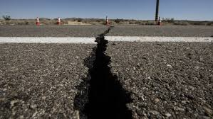
There will be famines and earthquakes in various places (Matthew. 24:7b).
Since the start of 2020, there are more than 2000 earthquakes that have taken place. If we think the time is going to be better, we are all mistaken as it does not align with scripture at all.

Plagues and pestilences
There will be great earthquakes, famines and pestilences in various places, and fearful events and great signs from heaven (cf. Luke. 21:11).
There are locus attacking South Africa, India, Iran and Pakistan. Hundreds and millions worth of crops are destroyed. There were forest fires in Australia that burnt the land equivalent to half the size of England. In Pastor Daniel’s opinion, God allows it to happen to humble the human being. We think we are in charge and in control. God sent something that is invisible to our eyes and it affect 97 countries in the world to humble all of us. Pastor. Daniel also believe there is a message God is sending to China and the whole world; that there are consequences of persecuting the churches as the church is the people of God and the apple of God’s eye.

Pressure, persecution, apostasy, betrayals and deception
Then you will be handed over to be persecuted and put to death, and you will be hated by all nations because of me. At that time many will turn away from the faith and will betray and hate each other, and many false prophets will appear and deceive many people. (Matthew. 24:9-11)
Jesus makes it clear that all these will happen and is happening now.

So, if all these are true, what is our response and what is the answer to the challenges we are facing?

What is God speaking us and calling us to do?

The Call

Know who we are:

The Body of Christ
Now you are the body of Christ, and each on of you is a part of it (1 Corinthians 12:27).
Unless we know we are the body of Christ, we cannot stand firm and steadfast in time of challenges. Jesus reminded us to be strong and rise up. Do not give in or give up in difficult times. We are also reminded to forgive and do not harbour hurt. Some chose to stop going to cell groups or church because they harbour hurt from another cell group or church members. We can only be strong if we leave our baggage behind.

The Bride of Christ
One of the seven angels who had the seven bowls full of the seven last plagues came and said to me,” Come, I will show you the bride, the wife of the Lamb” (Rev. 21:9) and Husbands, love your wives, just as Christ loved the church and gave himself for her to make her holy, cleansing her by the washing with water through the words, and to present her to himself as a radiant church, without stain or wrinkle or any other blemish, but holy and blameless. (Ephesians 5:25-27)
A bride is supposed to be pure, holy and blameless. Even in the face of challenges, we must not compromise in our life. Stay away from corruption and bribery. It may not be easy and we may get fired from a job. But it is better to have integrity rather than to compromise.

The Army of God
Finally, be strong in the Lord and in his mighty power. Put on the full armour of God, so that you can take your stand against the devil’s schemes. For our struggle is not against flesh and blood, but against the rules, against the authorities, against the powers of this dark world and against the spiritual forces of evil the heavenly realms. (Ephesians 6:10-12)
We must put on the armour of God to battle the evil and darkness. There is a power of the evil at work at the highest level. For examples, we have seven by-elections since GE14 and a young politician died from heart attack. Only when we equip ourselves, then only we can stand firm and resist and battle that evil.

Know what we are supposed to do
Because of the increase of wickedness, the love of most will grow cold, but the one who stands firm to the end will be saved. (Matthew. 24:12,13)

We are reminded stand firm, be steadfast, not giving in and not giving up. Unless we are build up strong, we have the purity and put on the armour of God, we will be easy target for the enemy. Some Christian who compromised becomes easy target of the enemy. They do not have integrity, stamina and strength to withstand the temptations. If we do not have integrity we are useless to God.

Know where is the key and the answer
The One enthroned in heaven laughs; the Lord scoffs at them. He rebukes them in his anger and terrifies them in his wrath saying, “I have installed my kingdom Zion, my holy mountains. (Psalm 2:4-6)

At the end, we must ask ourselves who is in charge in Malaysia. The way some Christians are praying, we do not believe Jesus Christ is in control in Malaysia. It is a tragedy that we panicked in the face of difficulties, especially during the coronavirus infection period. We must take extra precaution but not sow fear or respond to fear but must trust God.

Know who holds the hope and the future
“And I tell you Peter, and on this rock I will build my church, and the gates of Hades will not overcome it. “(Matthew. 16:18)
“Watch out that no one deceives you.” (Matthew. 24:14)

Hebrew 10:25 the author reminded that we must not giving up meeting together, as some are in the habit of doing. During ancient time, it was a serious disadvantage of being a Christian as they were persecuted. And yet they were meeting up in their hideouts in Catacombs in Rome. They continued to celebrate, had communion and even buried in the there. We must remind ourselves who holds the future and that our life is in God’s good hand. In Matthew 16:18, we are told that church of Jesus Christ will out- last everything. We are on the winning side. Two words to summarize Book of Revelation, “WE WIN”!

We hold the key and answer to the world’s problem. It was never the politicians. Pastor Daniel quoted Ben Carson, “We’ve been conditioned to think that only politicians can solve our problems. But at some point, maybe we will wake up and recognize that it was the politicians who created our problems.” We looked for the wrong people for help; the hope is you and I, the church of Jesus Christ.

Our Commitment

To our nation and her future
Ask me, and I will make the nations your inheritance, the ends of the earth your possession. (Psalm 2:8)
The future belongs to us. Psalm 2 reminds us to ask God for our inheritance. We must be bold and strong. Pastor Daniel encourages us to stay put in our country.

To our and all the future generation. We are concerned about our children and grandchildren and their future. Stay put and commit to them.
To the gospel and the cause of Christ’s Kingdom. We are here for the Gospel and to build the Kingdom of God for He last forever and ever.

Conclusion

The key is the Gospel of Christ and the power is the power of the Holy Spirit. Pastor Daniel shared an example how each of us can reach out to one person a year and how it would grow over time and we can win the world in only 33 years. Jesus said the harvest is plentiful 2000 years ago and 2000 years later we are far from finishing our job. We must repent and ask for forgiveness for our complacency. We must stop blaming others for our problems. We must believe that we hold the key to change the nation.

In such a time as this,
- How do we respond as Christian?
- What is our commitment?

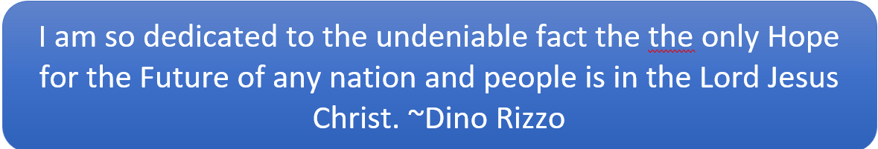

Sermon summary contributed by Dr. Felicia Chang

